# Building Gapminder in Tableau

Inspired by Hans Rosling’s Gapminder

https://www.ted.com/talks/hans_rosling_shows_the_best_stats_you_ve_ever_seen

This tutorial on building Gapminder in Tableau utilizes the World Indicators dataset. From the opening Tableau screen (or by clicking the Tableau logo in the top left corner), select the World Indicators dataset.

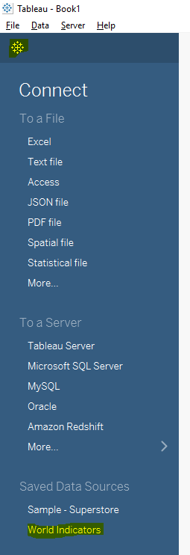 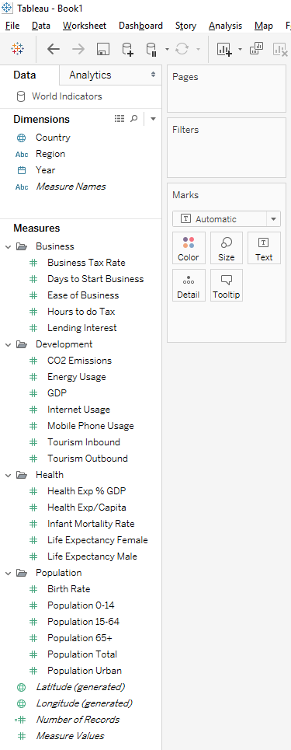

Once the data is loaded follow these step:

Move **Life Expectancy** Female to Rows and **Birth Rate** to Columns.

Move **Country** to Details on the Marks card.

Move **Region** to Color on the Marks card.

Move **Population Total** to Size on the Marks card.

Using the dropdown box on the Marks card, select Circles.

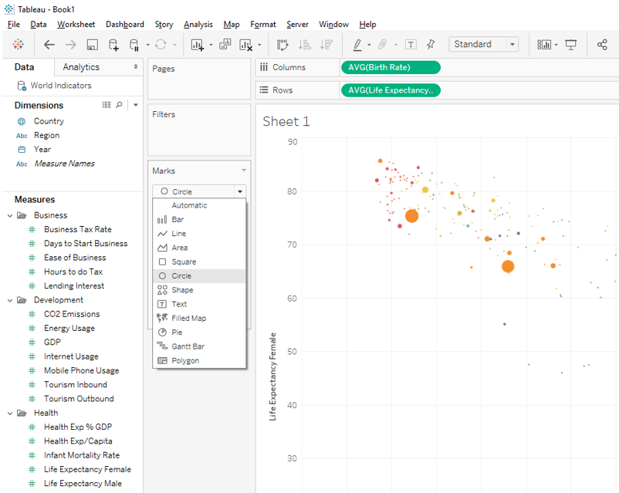

**Adjusting size and color:**

Select Size on the Marks card and adjust the size to make the circles larger.

Select Color on the Marks card and set Opacity to 65%.

Select Border and pick a medium gray color.

Note - the opacity and border is a useful tool when lots of dots plot on top of each other.

**Creating Animation:**

Move **Year** to Pages.

The visualization is now interactive. The play control will show up on the right-hand side of the Tableau canvas. The user can select year by year or hit the play control with the speed set to slow, medium or fast.

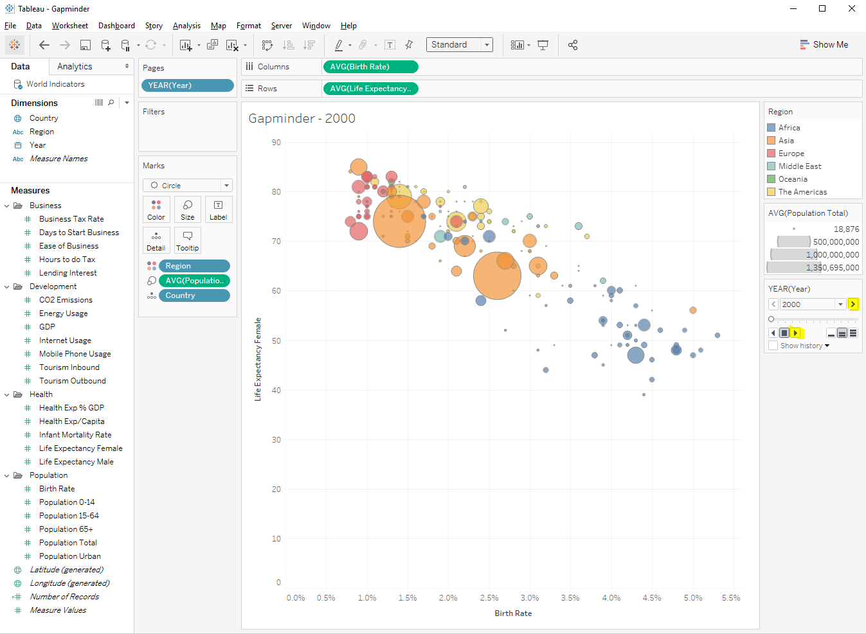

A full version of this visualization with a larger dataset is available for download from Tableau Public.

<https://public.tableau.com/profile/jeffs8297#!/vizhome/RoslinginTableau/RoslingGapminder>

A video of this visualization on YouTube.

<https://youtu.be/KdoBuNNvVec>